Air alert II
LEAP UPS with the rope
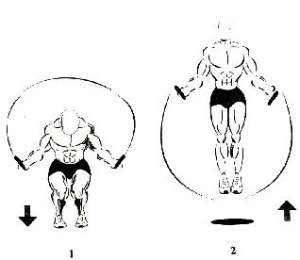
Step1: When beginning, bend down to a 1/4 squat position
Step2: Turn the rope and jump back into the air to a minimum of 8 to 10 inches. (You may jump 10 to 12 inches if this is too easy). When you land this completes 1 repetition.
Step3: Continue repeating this motion for each repetition
Rest about 3 to 4 minutes in between sets.
This exercise can be done without the use of a jump rope if you desire. When jumping, keep your hands by your side or in front of you for assistance in jumping and follow the same procedures just described. Please see the diagram below.
LEAP UPS without the rope
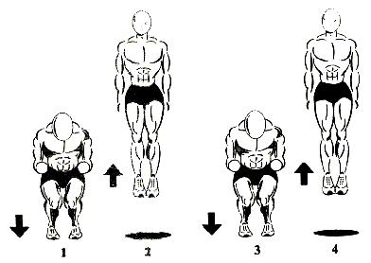
Step1: When beginning, bend down to a 1/4 squat position with your hands out in front of you and jump up
Step2: Jump up into the air to a minimum of 8 to 10 inches. (You may jump 10 to 12 inches if this is too easy) When in the air, your hands should be back by your side. When you land, this completes 1 repetition.
Step3: Same as step 1. Step 3 begins repetition 2
Step4: Same as step 2
Rest about 3 to 4 minutes in between sets.
Note: You do not have to do both types of Leap ups. Do only the type you are comfortable with.
CALF RAISES
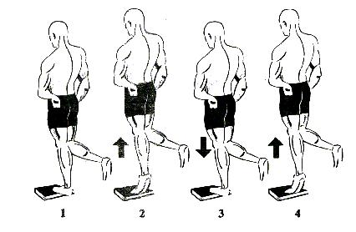
Step1: Your starting position will be with the heel below the book or stair step rested on by your entire body.
Step2: Raise yourself as high up as you can with only the one calf
Step3: Lower your body back to the original, starting position. This completes 1 repetition. Step4: begin second repetition.
Rest about 25 seconds in between sets.
STEP UPS
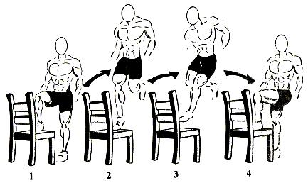
Step1: Begin with one thigh on the chair parallel to the ground.
Step2: With all of your strength, push off of the elevated leg and leap off of the chair as high as you can.
Step3: Crisscross or switch your legs in the air.
Step4: Land with the opposite leg elevated in the chair as in step 1. Repeat the procedure until you are back to step 1. This completes 1 repetition.
Rest about 3 to 4 minutes in between sets.
THRUST UPS
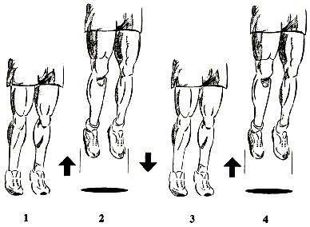
Step1: Begin with your legs straight.
Step2: Thrust (or bounce) yourself up as high as you possibly can.
Step3: The split second and you hit the ground, thrust back up as high as you can trying not to bend your legs. It is helpful to use your arms to throw yourself back up into the air.
Rest about 1 minute in between sets.
BURN OUTS
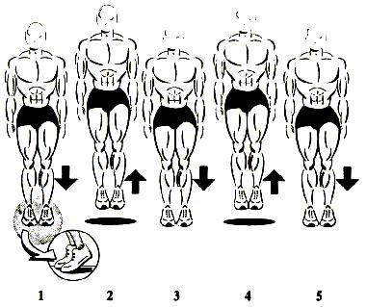
Step1: Elevated as high as you possible can on your tiptoes to assure that you work the high end of your claves.
Step2: As quickly as you possibly can, jump repeatedly no more than 1/2 to1 inch off of the ground making sure to keep yourself elevated as high on your tiptoes as possible ensuring that you are working the upper calf muscles.
OPTIONAL EXERCISES
Air Alert II is designed only to strengthen your thighs and calves. You must strengthen your hamstrings, which are the support muscles for the thighs to prevent from pulling or straining them when running or jumping. Strong hamstrings also help to prevent knee problems in the future. There are two ways to strengthen these muscles. The first is by sprinting and the second is by doing leg curls.
Sprinting: Sprinting or running as hard as you can is a good way to strengthen your hamstrings and an excellent way to increase your sprinting speed.
It is best to do 10, 50 yard sprints two times per week.
Make sure that you sprint as hard as you can making sure to bring your thighs up as high as possible towards your chest. This form works the centre muscle the best.
WORKOUT CHART
This workout chart will be your guide for each jumping exercise previously described. It is your weekly reference for the exact numbers of each exercise to follow. We recommend not altering the program methods.
Follow it precisely doing the appropriate number of sets and repetitions given.
A repetition is completing one motion of an exercise and a set is repeating a repetition continuously a desired number of times to complete a cycle. Jumping rope 100 times (the desired cycle) continuously with our resting is completing 1 set of 100 repetitions, and jumping rope 100 times continuously, then resting and jumping 100 times again is completing 2 sets of 100 repetition.
Do not overwork you muscles by doing too much but do not under work them either by doing too little. Do exactly what is offered and week by week you will see a steady increase in your jumping ability.
